Columbus Midtown Career Center

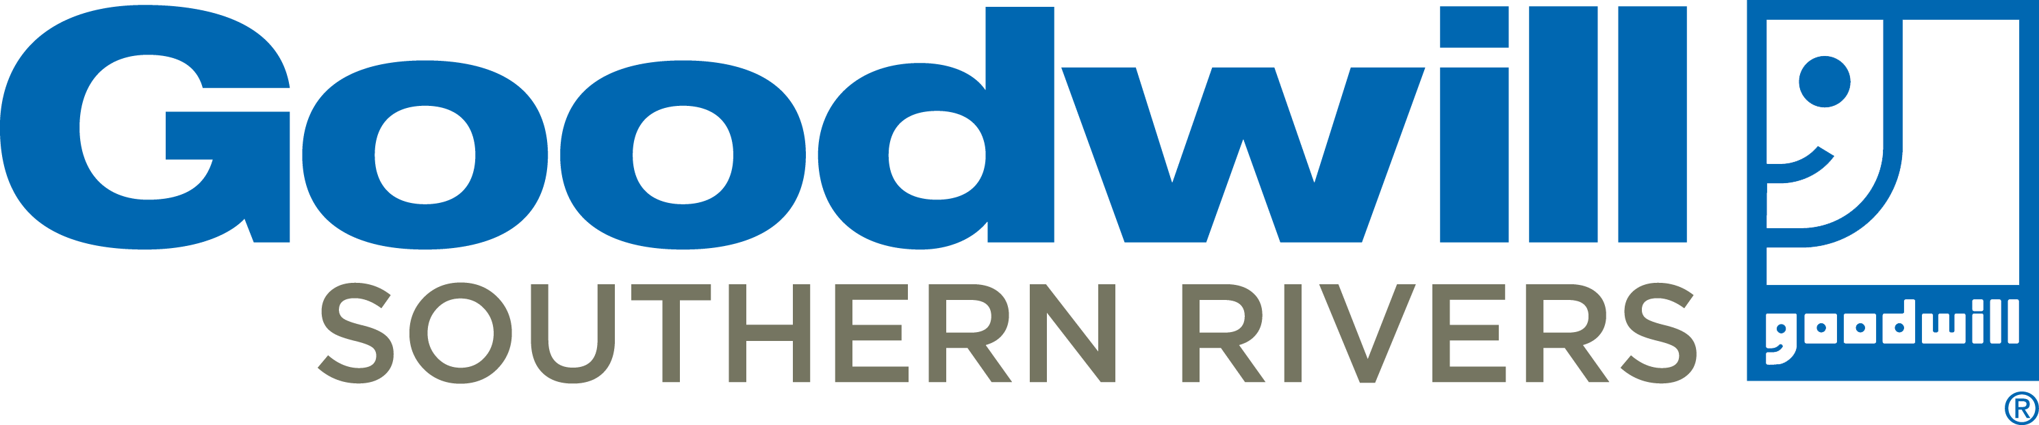
November, 2019
2601 Cross Country Drive | Columbus, GA | 31906
www.goodwillsr.org 706.256.1837
Monday – Thursday 9:00 a.m. – 6:00 p.m.
Friday 9:00 a.m. – 3:00p.m.

General Orientation is required and offered Monday – Thursday at 9:30am & 2:30pm and Friday at 9:30am

Mon  Ask a Career Center Specialist about:  VIP Program Benefits  GED classes  Ticket to Work  ESL (English Second-Language)  Resources to support your job search as a VIP client | Tue | Wed | Thu | Fri | Sat
 |  |  |  | 1 | 2  Job Search Tip  Identify your marketable skills – these are the skills you have that employers want.
Resume Workshop
10:30am

VIP Mock Interviews by
appointment

VIP Career Planning by
appointment
4 | 5 | 6 | 7 | 8 | 9
Conflict Resolution  11:00am  Communication Skills  3:30pm  VIP Career Exploration I 4:30pm | Work Ethics & Professionalism  11:00am  Job Searching  3:30pm  VIP Career Exploration II  4:30pm | Interview Skills  11:00am  Resume Workshop  3:00pm  We will close at 4pm for  staff training | Job Fair – Georgia Army National Guard 9am-1pm  Time Management  11:00am  Computer Skills & Email  3:30pm  Open Computer Learning at GCF Learn Free | Resume Workshop  10:30am  VIP Mock Interviews by  appointment  VIP Career Planning by  appointment | Job Search Tip  Be early! Avoid excess in your appearance.
11 | 12 | 13 | 14 | 15 | 16
Computer Skills & Email  11:00am  Open Computer Learning at GCF Learn Free  Time Management  3:30pm | Job Fair – Golden Donut  9am-12pm  Communication Skills  11:00am  Conflict Resolution  3:30pm  VIP Career Exploration I 4:30pm | Job Searching  11:00am  Work Ethics &  Professionalism  3:30pm  VIP Career Exploration II  4:30pm | WE WILL BE CLOSED AT OUR MIDTOWN LOCATION  JOIN US  Job Fair - HIRING HEROES  At Troy University  12pm – 4pm | Resume Workshop  10:30am  Finance Friday 12-1pm  Budgeting 101  VIP Mock Interviews by  appointment  VIP Career Planning by  appointment | Job Search Tip  Turn Off your cell phone before you meet someone in a job fair or an a interview.
18  Interview Skills  11:00am  Resume Workshop  3:30pm  VIP Career Exploration I 4:30pm | 19  DELAYED OPEN at 10 am  Time Management  11:00am  Computer Skills & Email  3:30pm  Open Computer Learning at GCF Learn Free | 20  Job Fair – Rutledge State Prison 9am-1pm  Conflict Resolution  11:00am  Communication Skills  3:30pm  VIP Career Exploration I I 4:30pm | 21  Work Ethics & Professionalism  11:00am  Job Searching  3:30pm  VITA Volunteer Information Session 4pm-7pm | 22  Resume Workshop  10:30am  VIP Mock Interviews by  appointment  VIP Career Planning by  appointment | 23  Job Search Tip  Focus on what an employer needs. Read the job decription carefully.
25  Job Searching  11:00am  Work Ethics & Professionalism  3:30pm | 26  Resume Workshop  11:00am  Interview Skills  3:30pm  VIP Career Exploration I  4:30pm | 27  Computer Skills & Email  11:00am  Open Computer Learning at GCF Learn Free  Time Management  3:30pm | 28  CLOSED FOR THANKSGIVING  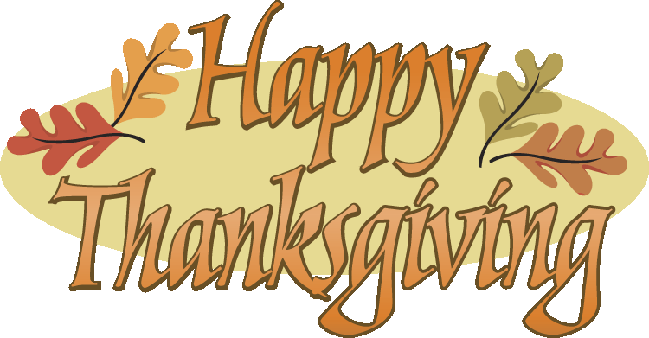 | 29  CLOSED FOR THANKSGIVING | 30  Job Search Tip  Identify and verify potential employers. And don’t put all of your options and energy into one employer.
Career Center VIP Program
Let us help you become “Career Ready”. Complete each of the classes on the Career Center VIP Program card to become a Career Center VIP. VIP services include:

- Entrance into a monthly gift card drawing (during the month of completion)
- Priority assistance with job searching, job applications, and resume preparation
- Referrals to “hot jobs”
- Early access to job fairs and other special events

See a Career Center Specialist today to become a VIP!
CALENDAR DETAILS
Orientation: All clients are required to complete orientation before use of services or resources. This class goes over the Career Center policies and gives an overview of the programs offered by GoodwillSR.
Orientation Schedule: 9:30 am & 2:30pm Monday – Thursday; 9:30 am Friday

We are closed for lunch daily from 1-2 and 1-1:30 on Fridays through January 25, 2019 – we will not close for lunch during VITA Tax Season.
VIP Career Exploration: This lab and workshop teaches you about you! You will learn about your personality in the workplace and filter through your career interests to gain a better understanding of the best career options for you. This will aid in a more successful job search.
Resume Workshop: This workshop teaches you how to write an effective and professional resume. Please bring work history (Employer name and address, position titles, dates, job descriptions), 4 to 5 references, and a list of everything you enjoy doing (i.e. fishing, drawing, event planning, etc).
Interview Skills Workshop: Learn how to WIN at the interview! The interview skills class is designed for any and everyone preparing for their next employment opportunity. This workshop will also cover how to “dress for success”.
Computer Skills & Email Workshop: This class covers basic computer skills. You are taught the basic skills needed to operate a computer for writing a resume, online job searching, etc. We will also cover e-mail basics and help create your own professional e-mail address if needed to assit you in your job search.
Time Management Workshop: Learn how to use your time effectively to be more efficient in the workplace.
Conflict Resolution Workshop: The purpose of this workshop is to teach you the proper way to handle conflict in the workplace. Many of the techniques can be applied to personal issues as well.
Communiction Workshop: To an employer, good communication skills are essential! Learn how active listening can improve the way you communicate with employers, co-workers, and customers and learn how to interpret information received from others.
Job Searching & Professionalism: This class will go over the latest trends in performing a successful job search. We will also cover key elements of professionalism in the workplace so once you get the job, you keep the job!
Work Ethics: This class will go over the difference between ethical and unethical behavior in the workplace. We will also discuss the consequences of unethical behavior in the workplace.
VIP Mock Interview: The interview might be the final step before you get the job! You have prepared, now let us help you put your knowledge to the test and practice an actual job interview with you. This mock interview will be tailored to fit the job description in which you are applying. Please dress for an interview, bring a job description of the postion you are interested in, and bring your resume!

