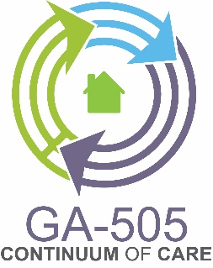
CoC Semi-Annual Meeting
Held 2:00 pm on March 6th, 2018
At Troy State University

Meeting Minutes
Present: See attached sign-in sheet showing 43 in attendance

Welcome
Mary Mayrose (chair) provided the welcome and introduction of the CoC board members in attendance.

Updates
Pat Frey (director, Home for Good), provided and narrated a Power Point presentation (copy in file). Information provided included Point-in-Time count update which noted a 1% decrease in homelessness and 25% increase in homeless families with children.

The HMIS system recorded 1,554 people that received services with 769 being new to HMIS. 81 housing placements were shown with 36% of those housed being veterans. The majority of the 81 being housed (48%), were housed through Rapid Rehousing.

CoC Committee Reports

Coordinated Entry (Candace Poole) – The “soft launch” of the coordinated entry system was January 2, 2018. There are still a few “bugs” being worked out. Paper intakes are available, and policy and procedures are on the website. 40 new unduplicated clients were entered in February.

Performance and Outcomes (Haley Ramey) – Working on a “user friendly” data report to include average benchmarks. Peer reviews are currently being scheduled.

Application – (Sandy Watson) – It was a difficult application this funding round and the CoC scored above the median. Application was submitted on Sep 26, 2017 and funded at 100%. The bonus project was not awarded funding (but most were not)

Mainstream and Outreach (Kim Taylor) – Committee has been “hands on” with the clients to educate and become a “one stop shop”. A job fair was held in conjunction with the PIT count with 15 hires. A community outreach is planned in June with Columbus and Phenix City.

HMIS (Tiffany Cole) – HMIS is going great and plans to have trainings scheduled by the end of March.

Pat Frey gave a brief overview of committees and encouraged all in attendance to review the committee descriptions on display and sign up to participate on at least one committee.

Presentation

Rabbi Schwartz and Chair, Mary Mayrose presented a certificate of appreciation to Board Secretary, Beverly LaMee, who is retiring and resigning from the CoC.

Other Business

Denise McWhorter encouraged those in attendance to attend a public meeting on March 20, 2018 regarding Columbus’ Annual Action Plan.

Haley Ramey spoke on the Phenix City Housing Authority’s fund raiser, a 3 on 3 basketball tournament being held on March 31, 2018. The program is entitled “Hoop There it is” with flyers being emailed to all in attendance.

Rabbi Schwartz and Chair, Mary Mayrose spoke on the importance of partnership and reminded that, these are families and people with names; not just beds and numbers.

There being no further business, the meeting was adjourned at 3:00 pm.

